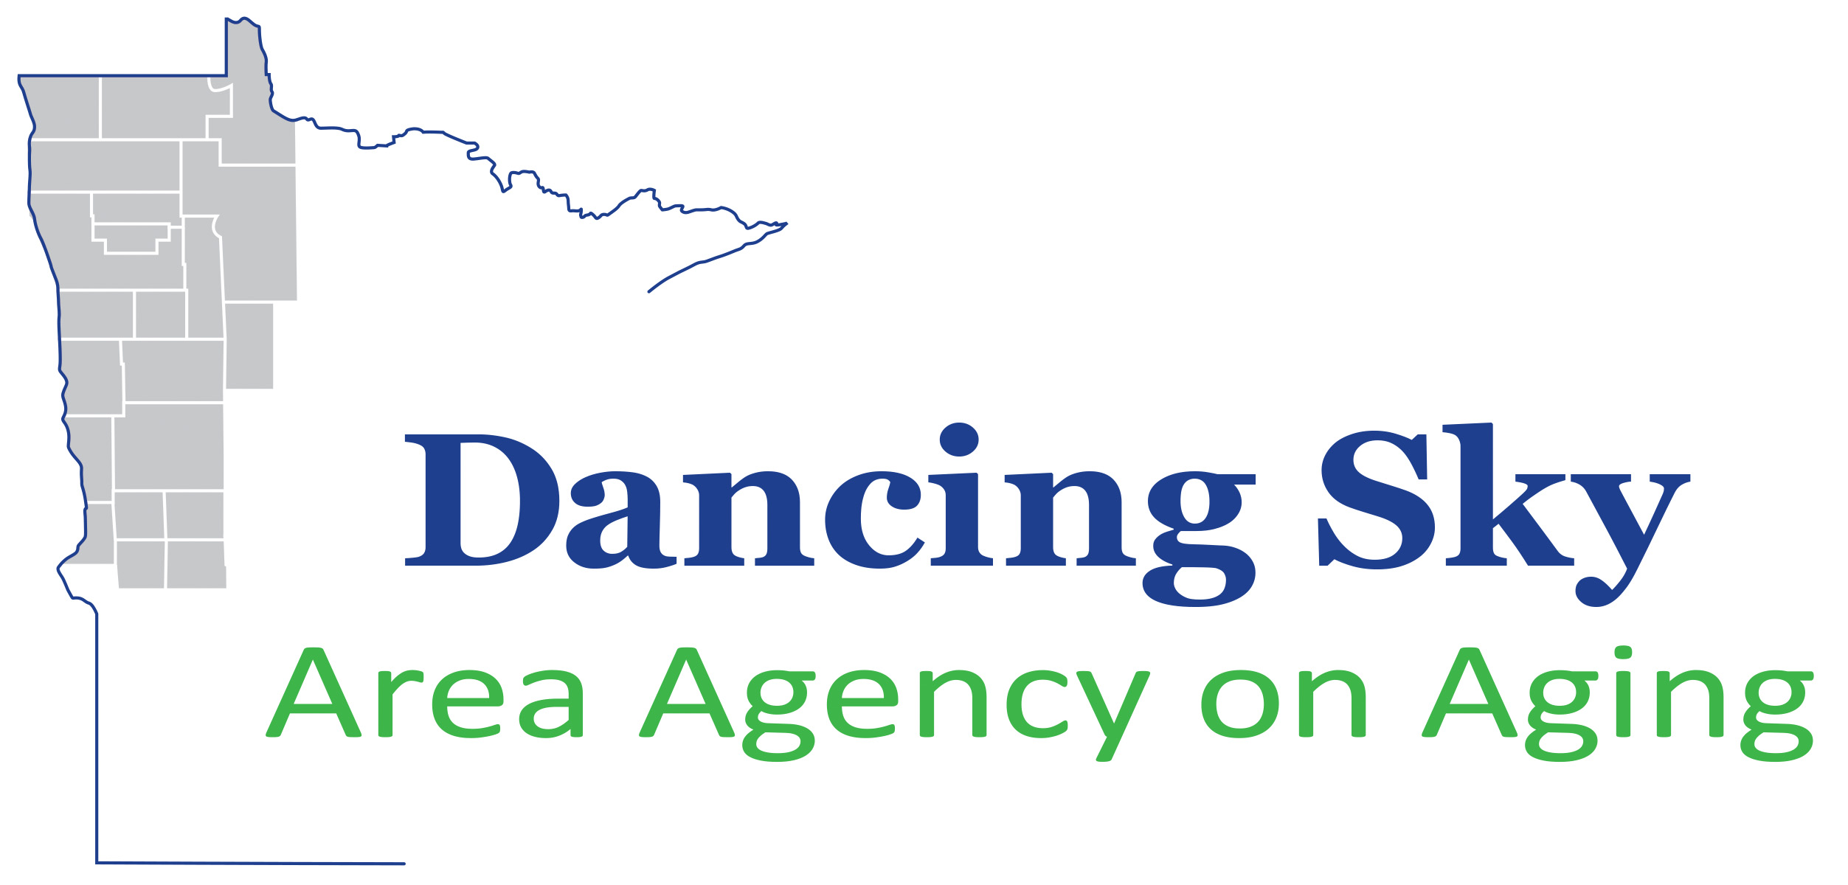Proposed Program Outcomes
DSAAA Required Outcomes:
- Develop better targeting of members of diverse communities. Include a discussion around efforts to increase the numbers of minority persons served with Title III funds.
- Utilize and/or distribute the Live Well at Home Rapid Screen platform with clients.
- Use a survey created in conjunction with DSAAA to measure quality and consumer satisfaction of services.

Program: ___________________________

Long Term Outcomes | Short Term or Intermediate  Outcomes  (Desired Changes/Benefits) | Program Outputs  (Activities, service units, number of participants & timelines) | Performance Standard/Benchmark  Evaluation Method

Insert Rows as needed.

Land of the Dancing Sky Area Agency on Aging Proposed Program Outcomes
Program: Caregiver Support Services

Long Term Outcomes | Short Term or Intermediate  Outcomes  (Desired Changes/Benefits) | Program Outputs  (Activities, service units, number of participants & timelines) | Performance Standard/Benchmark  Evaluation Method
1. Reduced caregiver burden.  SAMPLE  2. Increase caregiver access to support services. | Caregivers will receive services that support them in and reduce the stress of caregiving responsibilities.  Caregiver’s of Hispanic elders will be identified and receive information on services available. | January – December 2002  A comprehensive needs assessment will be completed with 135 families.  800 hours of consultation will be provided to caregivers in need of assistance to arrange services.  Contact 4 faith based organization serving the Hispanic community to request assistance in identifying caregivers. | 65% of caregivers served will self- report that services they received reduced their direct responsibility for caregiving tasks.  Annual Caregiver Satisfaction Survey.  10 caregivers will be identified by  staff from faith-based organizations.  Referral source data will be tracked by type of organization.

